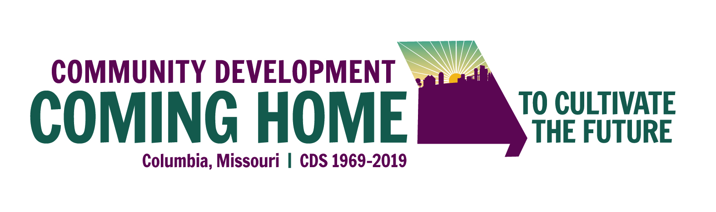
CALL for STUDENT POSTERS
for the Community Development Society’s
50th Anniversary Celebration
& Annual International Conference

July 14-17, 2019 -- Columbia, Missouri, USA
at the University of Missouri -- Birthplace of CDS

CALL FOR STUDENT POSTER ABSTRACTS
The Community Development Society (CDS) is requesting proposals for STUDENT posters relating to community development for presentation at the 2019 Community Development Society Conference, July 14-17, 2019 in Columbia. Missouri, USA – the founding home of CDS. Submissions relating to the conference theme, “Community Development: Coming Home to Cultivate the Future” are encouraged, but all submissions will be given full consideration.
The deadline for submission of poster proposals is April 26 at 11:59 p.m. EST. See theme narrative below to get a sense of what will be presented throughout the conference.
The Poster Session will be held on Tuesday, July 16, from 3:30 to 4:30 p.m., at the main conference venue, the Bond Life Sciences Center, on the University of Missouri-Columbia campus. Posters will be up on display before and after this session.

Abstract Submissions for Posters – General Information:
(Maximum 500 word abstracts which does not include references or title page)
  - Research Posters include, but are not limited to: empirical research, action or participatory research, and theoretical/philosophical perspectives.
  - Practitioner Posters include, but are not limited to: innovative ideas and practices, programmatic successes and reflections.
Rules for Proposal Submission:
- You may submit more than one proposal.
- The deadline for abstract proposal submissions is April 26 at 11:59 p.m. EST. No late abstracts will be accepted.
- All accepted proposal presenters must complete their paid registration for the conference by June 14, 2019. Please note, presenters do not receive free registration – there is a student rate.
- If you are not a member of CDS at the time of your conference registration, please register at the non-member level fee (includes a one-year student membership to CDS).
- Conference program copy will be finalized by July 1, 2019.
Required Format for Abstracts:
Title Page: List title of your abstract, name(s) and institutions/organizations of each author. For the lead author only, include contact information (mailing address and email address). Include up to five keywords that describe your abstract.
Abstracts content: The abstract should accurately communicate how your proposal relates to community development and the 50th anniversary theme. It should be double spaced, Times New Roman, 12-point font. No author names or identifying information should appear in the abstract. Abstracts must be no more than 500 words.
- Word count does not include references or title page
Elements of the Abstract for Poster Submission:
- Title of Poster Submission
- Lead Author’s (Student) Name
- Lead Author’s Affiliation (University and Program)
- Name of Faculty Advisor (if applicable) / is this project connected to a class or capstone project (e.g. thesis)
- Address
- Phone Number
- Email
- 2nd Corresponding Author’s Name
- Corresponding Author’s Affiliation
- 3rd Corresponding Author’s Name
- Corresponding Author’s Affiliation
Keywords: (Please list three key words related to your submission)
Potential Abstract Headings:
Educator/Practitioner Abstract Headings:
- Introduction
- Background Information
- Program Design & Description
- Results
- Conclusions/Implications & Recommendations for Practice
Research Abstract Headings:
- Introduction
- Literature Review/Theoretical Framework
- Research Methods
- Results
- Conclusions/Implications & Recommendations for Further Research/Practice
How to submit:
- Save your abstract proposal in Word (.docx) format
- Send to Jane Leonard, the 2019 Conference Program Chair, at jane@growthandjustice.org
- You will receive a confirmation e-mail that your proposal was successfully received.
Review Process & Conference Information:
Each proposal will be blind-peer reviewed by CDS members. Abstracts will be evaluated based on novelty, contribution to the field of community development and quality of the research/practitioner-based project.
Main contacts for the poster submission will be notified of the review decision via email on or before May 6, 2019.
Here is a link to the conference information, https://www.comm-dev.org/networking/2019-conference including hotel lodging and dorm options https://www.comm-dev.org/lodging-3
Please note, there are student rates for registration and lodging is available in two conference hotels at $149/night (reserve before June 12 to get that rate) or in dormitories on campus at $32-$57/night depending on single or double lodging. (Dormitory room blocks will be held until May 10 – please reserve a room before this if choosing the dorm option.)
Program Contact:
Jane Leonard
V.P. Programs, CDS
President, Growth & Justice, Minnesota USA
Tel. (651) 303-5263
Email: jane@growthandjustice.org

CONFERENCE THEME NARRATIVE:
CDS ANNUAL INTERNATIONAL CONFERENCE AND 50TH ANNIVERSARY THEME:
COMMUNITY DEVELOPMENT: COMING HOME TO CULTIVATE THE FUTURE
Join Us. Where it all started. 1969. Turmoil, seismic change.
Response: Community – Development - Society.
Sound familiar? It’s now 2019 - Back to the future!
The 50th anniversary of the international Community Development Society (CDS) is a golden opportunity to express and explore the extreme relevance and responsibility of the community development field and CDS to be proactive change agents, to help create conditions for and help foster shared and welcoming communities, and to cultivate a future in which community is the pathway through rising chaos and insularity across our world.
It’s a chance for CDS members, and for any and all colleagues, to remember and re-embrace the ideals with which our founders also struggled, to articulate what was happening and what they could do to help amidst the chaotic change of the 1960s. The chaos then compelled them to join forces and form an association of people who believed in the pathway of community to help channel destructive anger into constructive, collaborative, and inclusive citizen-led community-building.
In fact, our founding leaders made clear that community development is “a radical profession….based on the belief that people can give purposeful direction to their collective future. How this occurs is based on the community, the issues, the current capacity of people and the resource base that is present…Community development is gaining knowledge and empowerment through a process of collaboration and action.” (Practicing Community Development, Donald W. and Doris P. Littrell, University of Missouri Extension, 2006)
The theme for our 50th anniversary program calls upon on our own skills to reflect, collaborate, and then act to plant the seeds for our next 25 years, to cultivate our future, as CDS members, as community development researchers, scholars, practitioners, and, perhaps most importantly as ambassadors of CD in the many communities, organizations, and institutions in which we participate -- in life and in work.
“Cultivating the Future” evokes an invitation for and creativity in research, practice, policy, and theory to be shared in 2019 that offer a glimpse of the next 25 years for community development research and practice. We also seek proposals that showcase what we’ve learned in the past 50 years that still inform our work now, and also what’s ahead in the way of tools, insights, processes, challenges and opportunities. For example, 25 years ago, the Internet was barely on the horizon. Now it’s totally changed how we process information, do business, and relate to one another (or not) within communities and across the world.
How do we hold onto our essential and long-standing roots – our guiding principles noted below -- to weather the storms of current day? What, why, and how do we research, teach, guide, and champion positive change for communities -- to embrace diversity, equity, and inclusion as essential, intentional seedlings necessary to be able to nurture and grow to maturity the sustainable community, economic, and environmental vitality we seek for all, amidst the tumults of 21st century geopolitical life?
Much is the same as 50 years ago: waves of radical action and radical grace in the face of community and world-wide disruptions. Much has changed. We are more fragmented even as we are more widely and thinly connected. Community is fragile, beloved, and yearned. How can we help cultivate a future seeking and needing community to thrive?
How do we, as community development practitioners, researchers, scholars, and community members, take up the baton from our founders and cultivate the future sorely in need of our skills, insights, and leadership? Reflect on our guiding CDS Principles of Good Practice (listed below) as you consider your contributions to the conference. Then help answer all or some of the questions posed here as you assemble your proposals and plan for participation in the 50th anniversary and 51st gathering of the Community Development Society, in our shared and founding home of Columbia, Missouri, USA.

CDS Principles of Good Practice
As a part of the CDS beliefs, the organization and its members follow the core CDS Principles of Good Practice:
- Promote active and representative participation toward enabling all community members to meaningfully influence the decisions that affect their lives.

- Engage community members in learning about and understanding community issues, and the economic, social, environmental, political, psychological, and other impacts associated with alternative courses of action.

- Incorporate the diverse interests and cultures of the community in the community development process; and disengage from support of any effort that is likely to adversely affect the disadvantaged members of a community.

- Work actively to enhance the leadership capacity of community members, leaders,
and groups within the community.

- Be open to using the full range of action strategies to work toward the long-term
sustainability and well-being of the community.

